

**AIR FORCE SCHOOL**

**CHANDAN NAGAR, PUNE**

**9brd**

**A**

**PROJECT REPORT ON**

**AI ASSISTANT**

**SUBJECT: COMPUTER SCIENCE**

**2020-2021**

**NAME: devang dixit**

**CLASS: 12TH Science**

**ROLL NO: 11 EXAM SEAT NO:**

**DEPARTMENT OF COMPUTER SCIENCE**

**AIR FORCE SCHOOL, 9BRD**

**CHANDAN NAGAR, PUNE**

**CERTIFICATE**

**This is to certify that Mr. Devang Dixit of Class XII Science of Air Force School, 9BRD Chandan Nagar, Pune has completed his project file under my supervision. He has taken proper care and shown utmost sincerity in completion of this project.**

**I certify this project is up to my expectation as per the guidelines issued by CBSE.**

**SUBJECT TEACHERS**  **EXTERNAL EXAMINERS**

**SIGN**   **SIGN**

**PRINCIPALS SIGN**

**ACKNOWLEDGEMENT**

**I would like to convey my heartfelt thanks to Mrs. Monali Gavali Computer teacher who has always gave valuable suggestions and guidance during the completion of this project. She has been a source of inspiration during the completion of my project work. She helped me to understand and remember important details of the project. My project has been a success only because of her guidance.**

**Devang Dixit**

**Class XII Science**

INDEX

|  |  |  |
| --- | --- | --- |
| S.no | content | Page n0 |
| 01 | INTRODUCTION OF THE PROJECT | 1 |
| 02 | FUNCTIONS USED | 2 |
| 03 | WORKING DESCRIPTION | 3 |
| 04 | CODING | 4 |
| 05 | OUTPUT | 9 |
| 06 | COCLUSION | 12 |
| 07 | BIBLIOGRAPHY | 13 |

INTRODUCTION OF THE PROJECT

AI Assistant is a program that works similar to the google assistant but only for pc’s, laptops. It helps the user to solve basic math problems, give the answer to the G.K. questions and also search the information for the user on the internet.

**Functions used**

1. speech_recognition: It recognizes the speech said by the user
2. time import ctime: It is used to display the current time
3. time: It is used to give a pause to the program when necessary
4. Os: It is responsible for the tasks related to the operating system.
5. gTTS: It is used for the text to speech.
6. Webbrowser: It is used to perform browser related tasks.
7. Datetime: It is used for the date and time
8. Pyttsx3:It works similar to gtts but it also works offline.
9. Os.path: It is used to get the path of the softwares in the os.
10. Requests:It is to send all kinds of HTTP requests.
11. Wolframalpha:It is an API.

**WORKING DESCRIPTION**

This program asks for the name and recognizes the speech to perform the tasks. It also saves the history of login and speech said.

import speech_recognition as sr

from time import ctime

import time

import os

from gtts import gTTS

import webbrowser

import datetime

import pyttsx3

import os.path

import requests

import wolframalpha

engine=pyttsx3.init('sapi5')

voices=engine.getProperty('voices')

engine.setProperty('voice','voices[0].id')

engine.setProperty('rate', 150)

engine.setProperty('volume', 1.0)

inidir=os.path.realpath('history')

def speak(text):

engine.say(text)

engine.runAndWait()

def recordaudio():

r = sr.Recognizer()

with sr.Microphone() as source:

print("I am listening.")

speak("I am listening.")

audio = r.listen(source)

data = ""

try:

data = r.recognize_google(audio)

print("You said: " , data)

obj = open(completeName,'a+')

obj.write(data)

except sr.UnknownValueError:

print("Sorry. Could not recognise the audio.")

time.sleep(7)

except sr.RequestError as e:

print("You are not connected to the internet.".format(e))

speak("You are not connected to the internet.".format(e))

os.system("pause")

return data

def Nexus(data):

if "tell me the time" in data:

strtime=datetime.datetime.now().strftime("%H:%M:%S\n")

speak(f"the time is {strtime}")

obj = open(completeName,'a+')

obj.write('\n')

obj.write(strtime)

print(strtime)

if "where is" in data:

data = data.split(" ")

location = data[2]

speak("Hold on "+nam+", I will show you where " + location + " is.")

webbrowser.open_new_tab('https://www.google.co.in/maps/place/'+ location)

obj = open(completeName,'a+')

obj.write(location)

print('I found',location)

if "open" in data:

data = data.split(" ")

op = data[1]

speak("openng"+op)

webbrowser.open_new_tab('https://www.'+ op +'.com')

obj = open(completeName,'a+')

obj.write(op)

if "exit" in data:

print("Thank you for having me.")

speak("Thank you for having me.")

time.sleep(2)

exit()

if "show today's news" in data:

webbrowser.open_new_tab('https://news.google.com/topstories')

obj = open(completeName,'a+')

obj.write('news\n')

if "search" in data:

data=data.split(" ")

ss=data[1:]

webbrowser.open_new_tab('https://www.google.co.in/search?q='+str(ss))

obj = open(completeName,'a+')

obj.write(str(data))

if 'find' in data:

speak('I can answer to computational and geographical questions and what question do you want to ask now')

question=recordaudio()

app_id="4Y54E6-PARTUHG742"

client = wolframalpha.Client('R2K75H-7ELALHR35X')

res = client.query(question)

answer = next(res.results).text

speak(answer)

print(answer)

obj = open(completeName,'a+')

obj.write(question)

obj.write(answer)

time.sleep(3)

nam = input("Enter your name:")

completeName = os.path.join(inidir, nam+".txt")

obj = open(completeName,'a+')

obj.write('user name:'+ nam)

obj.write('\n')

obj.write('Start time:'+datetime.datetime.now().strftime("%H:%M:%S\n"))

obj.write('\n')

obj.write('End time:'+datetime.datetime.now().strftime("%H:%M:%S\n"))

obj.write('\n')

obj.close()

speak("Hi "+nam+", what can I do for you?")

while 1:

data = recordaudio()

Nexus(data)

**OUTPUT:**

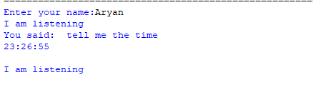



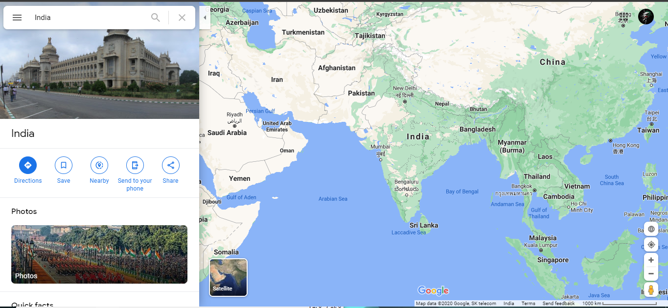



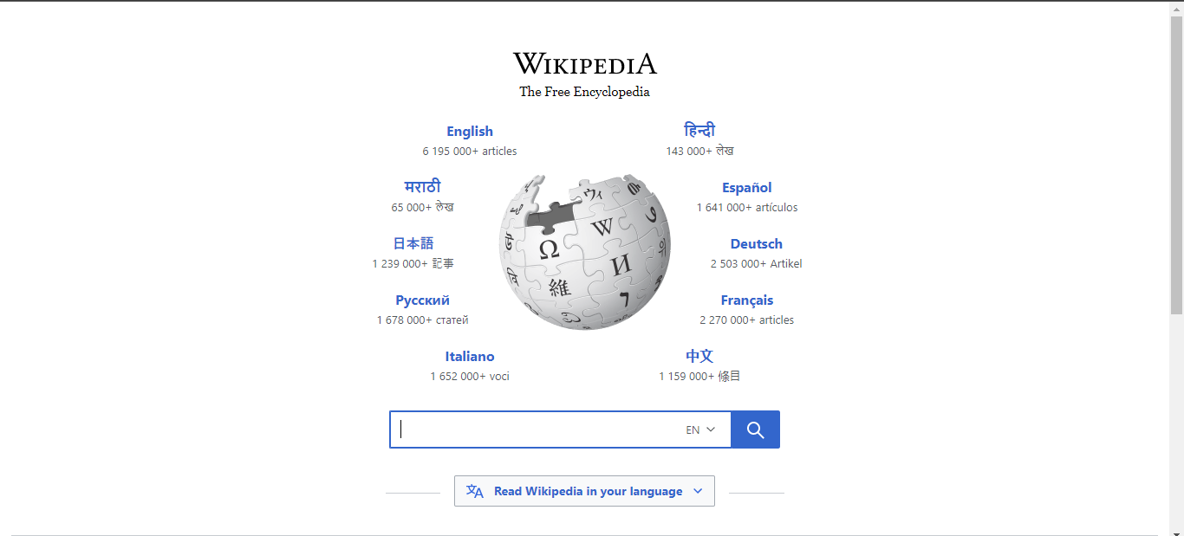



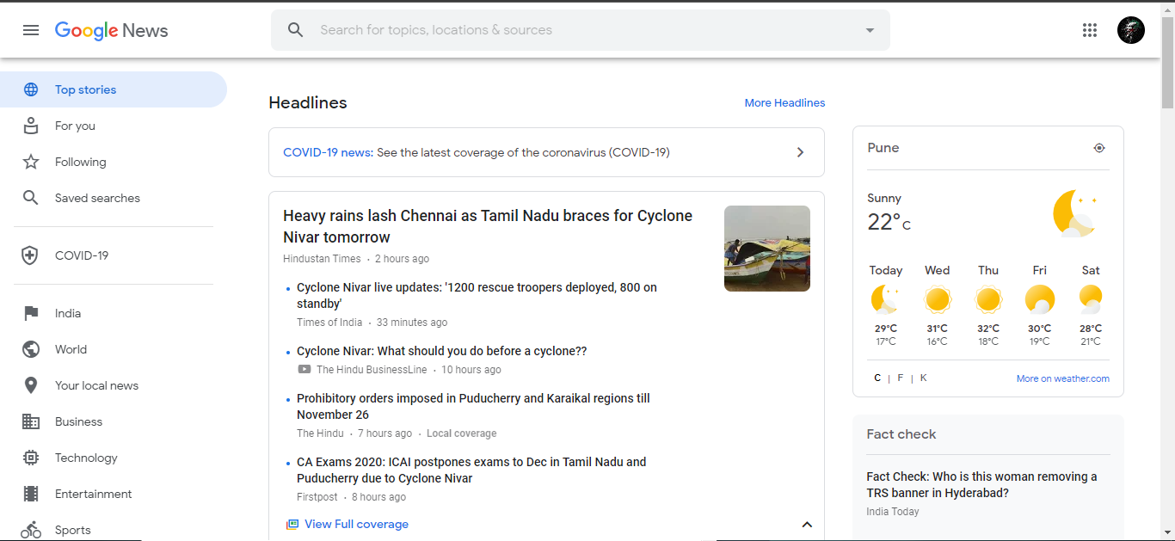

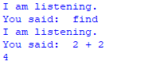

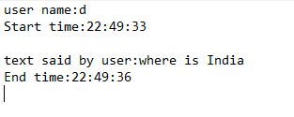

**conclusion**

“AI ASSISTANT” program is very interesting and easy to use program which will help people to search for any information in fraction of time.

This program will also help the physically challenged people to access the pc/laptop with less trouble

**Bibliography**

**WEBSITES:**

1. www.geeksforgeeks.org

2. www.w3schools.com

3. www.python.org

**BOOKS:**

1.SUMITA ARORA CLASS11

2. SUMITA ARORA CLASS12